**Curriculum Vitae**

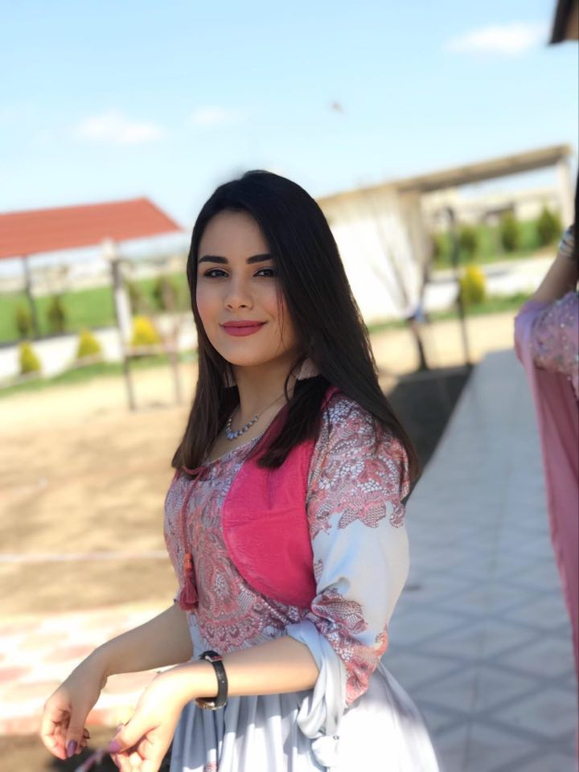

|  |  |  |  |  |  |
| --- | --- | --- | --- | --- | --- |
| **PERSONAL AND CONTACT INFORMATION** | | | | | |
| **Full Name:** | Danya Diyar Maghdid | | | | |
| **Date of Birth:** | 29/05/1999 | | | | |
| **Gender:** | Female | | | | |
| **Nationality:** | Kurdish | | | | |
| **Marital Status:** | Single | | | | |
| **Address:** | Erbil, Kurdistan Region, Iraq | | | | |
| **E-Mail:** | Danya.3404869@gmail.com | | | | |
| **Mobile:** | **07510520639** | | | | |
| **LANGUAGES** | | | | | |
| **Language** | | **Read and Write** | | **Speak** | |
| Kurdish | | Native | | Native | |
| English | | Very Good | | Very Good | |
| Arabic | | good | | good | |
| **EDUCATION** | | | | | |
| **Degree** | | | **university** | | **Year** |
| Software engineering graduate | | | Salahaddin | | 2019-2020 |

O

|  |  |
| --- | --- |
| **Computer Skills** | |
| **Operating System:** | Windows 7 and 10 and Macintosh |
| **Software Package:** | Microsoft Office (Word , Excel , PowerPoint) |
| **Programming:** | * Java * C++ * database |
| **Employment and**  **Training with certificate** | -Sales manager at dream way avation (july/2019-sep/2019)  - Sales manager at sabre travel network (july/2019-sep/2019)  -amazon book store (jan/2019-mar/2019)  -Sedaf 2019  -rwan organization 2019 |